• | What do you think this story will be about? What role will the monkey’s paw play? |  | What do you think the consequences of Mr. White’s wish will be?
∆ | Jot down your thoughts on what the Whites will do next. What would you do? |  | 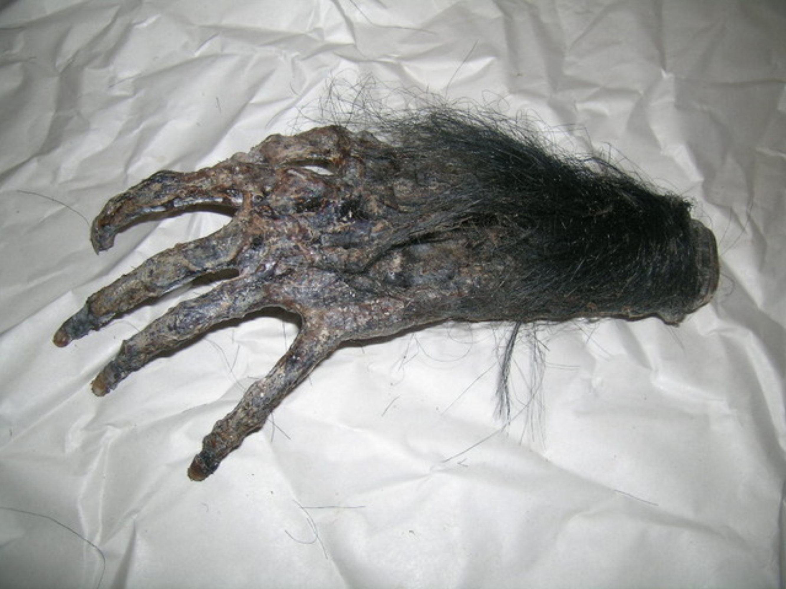  What do you think will be the result of the second wish?
* | What was the third wish? Did you predict it?

- Are the Whites’ three wishes granted? Do they get what they really want? Explain, yo!

- What did the holy man want to prove to people by putting the spell on the paw? In your opinion, has the holy man made his point? Why or why not?

- How could the first wish have been worded to avoid the tragic consequences? the second wish?

- What things does the sergeant major say that foreshadow, or hint at, the Whites’ fate? Note the page number along with the quoted text.

- Compare Mr. White’s and Herbert’s attitudes toward the monkey’s paw. Why is it logical that Herbert would be the victim of the first wish?

- Unlike Mr. White’s first two wishes, the third wish doesn’t seem to have unexpected disastrous consequences. Do you think the granting of the third wish will also produce a tragic outcome? If so, why might it be?

- Do you think that it is believable that, knowing what he does, the sergeant major continues to carry the paw and then allows a friend to wish on it? Defend your position.

