The Monroe Doctrine

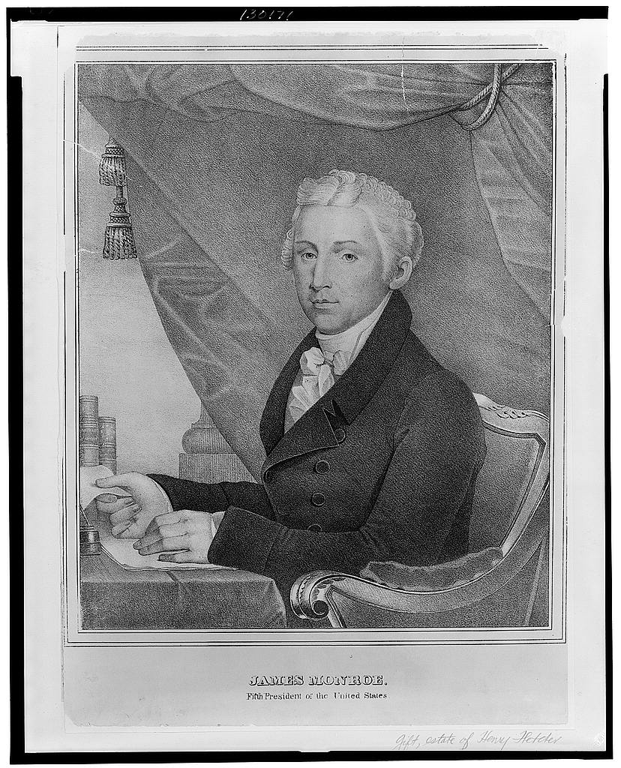

Proclamation in 1823 by
President James Monroe

Basically, it warned Europeans nations not to get involved in political matters in Central and South America. The doctrine was intended to show that the United States was the only country that could influence such political matters. Based on Secretary of State John Quincy Adams’ diplomatic or foreign policy, the Monroe Doctrine would become the long-lasting foundation of American policy that we, arguably, still use today!

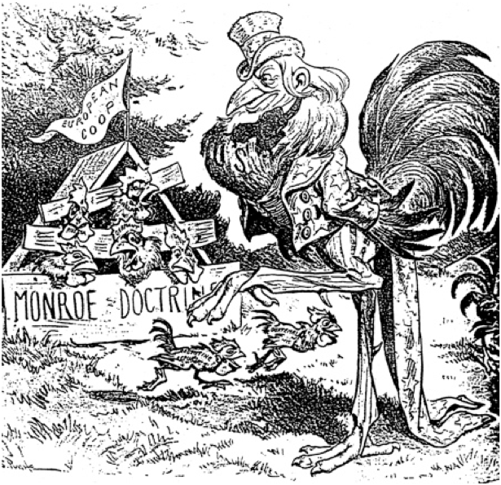
Political Cartoon #1 Discussion Questions

- What is happening in the cartoon?

- Who does the figure in the foreground represent?

- Who are the figures in the background? See if you can read the names of nations.

- What is the message of the cartoon?

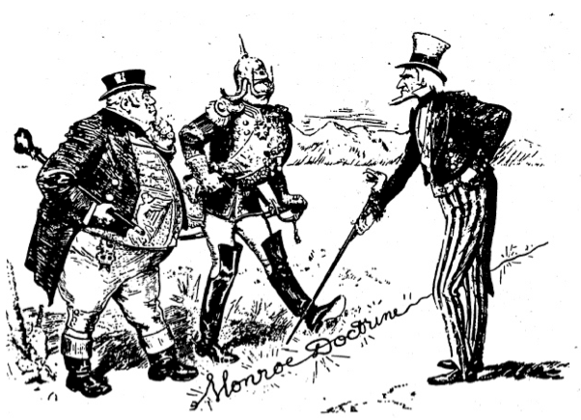
caption: “The Monroe Doctrine: A Live Wire!

Political Cartoon #2 Questions
- Describe what is happening in this cartoon.

- Who is the figure on the right?

- Who are the two figures on the left?

- What is the figure on the right pointing to?

- What is the message of the cartoon?

- Who does the gentleman on the right side represent?

- According to the caption, what does the terminology, “A Live Wire,” mean?

- If you stepped on the “Monroe Doctrine” what would happen?

- What does “diplomacy” mean?

Excerpts from the Monroe Doctrine of 1823
The occasion has been judged proper for asserting…that the American continents…are henceforth not to be considered as subjects for future colonization by any European powers…

The political system of the allied powers is essentially different…from that of America. We…declare that we should consider any attempt on their part to extend their system to any portion of this hemisphere as dangerous to our peace and safety…

With the existing colonies…we have not interfered and shall not interfere. But with the governments who have declared their independence and maintained it, and whose independence we have…acknowledged, we could not view any [interference] for the purpose of oppressing them…by any European power in any other light than as the [evidence] of an unfriendly [attitude] toward the United States.

- According to this document, whom does the Monroe Doctrine warn? Circle where Monroe names those countries.

- The second paragraph explains how the United States will react to “any attempt on their part to extend their system to any portion of this hemisphere.” What does that quoted section mean?

- How will the United States “interpret” that action from question 3?

- Check out page 301 in your textbook. Read the four tenets (or main ideas) of the Monroe Doctrine are listed there. This policy has been very important to the development of American diplomacy to this day.

Monroe claimed that Latin America was within the United States’ “sphere of influence” – this means that the United States is interested in the well-being and development of nearby nations and may claim some control over. Consider the many African nations the U.S. provides resources for, Iraq, or even Afghanistan today. The United States sends billions of dollars to foreign countries every year to assist with their development and protect them…

Why do you think President Monroe (and the United States today!) really wanted to “protect” the Latin American countries?

