Plot Elements: the series of related events that make up a story
- Exposition: The introduction! It tells us who the characters are and what their CONFLICT is.
  - Setting: Where and when the story takes place
  - Mood: The emotional feeling the reader gets from the setting and character description; the atmosphere.
  - Tone: The attitude of the speaker or narrator.
  - Characters
    - Protagonist: The main character of the story; who the story is about; this character sets the action in motion
    - Antagonist: The character or force that opposes the protagonist.
    - Dynamic character: one that changes throughout the course of the story
    - Static character: one that does not change throughout the story
- Rising Action (Complications, problems, events): Contributing factors to the conflict and the complications that arise as the characters take steps to resolve that conflict. Typically the part of the story where the protagonist meets the antagonist. Also, this is when an author will typically begin building
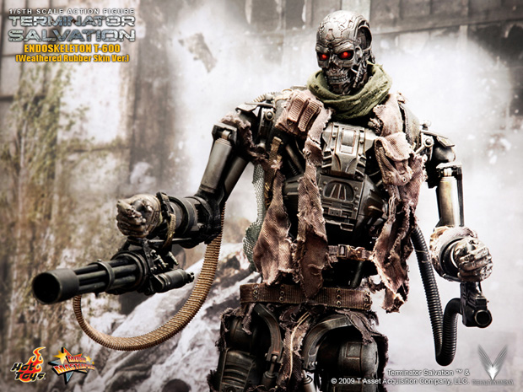
  - Conflict: One force meets an opposing force. External Conflict is one force against an outside force, something other than itself. Internal Conflict is one force battling with itself.
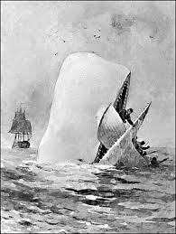
    - One Person vs. Another Person
    - Person vs. Nature
    - Person vs. Himself or Herself
    - Person vs. Society
Human vs. Machine
Don’t mess with this robot. He’ll kill you…and then probably eat you, too.
Human vs. Nature
Don’t mess with this whale. He’ll eat you.
    - Person vs. Machine/Technology
    - Person vs. Fate, Destiny, God

- Climax: The point at which the reader can see who will inevitably win the conflict.
This can often not be seen until the story is over and the reader looks back on the plot.

- Resolution: The point at which the conflict is resolved and/or the story is brought to a close. A story does not always need to have a satisfying resolution. Sometimes an author prefers to keep the reader guessing even after the story ends (“The Landlady,” “The Monkey’s Paw,” and “The Tell-Tale Heart” are all examples of this unsatisfying or open resolution.)

- Dénouement: This is French for “unknotting” and is essentially the wrapping up of all the loose details of the plot in order to satisfy the reader or audience

- Other Methods to Create Suspense in a Story (SUSPENSE: uncertainty about what will occur next in a story)
  - Mystery: when an author withholds information from the reader
  - Dilemma: When a character is confronted by serious problem or choice
  - Reversal: a sudden change in a character’s situation from good to bad or bad to good

