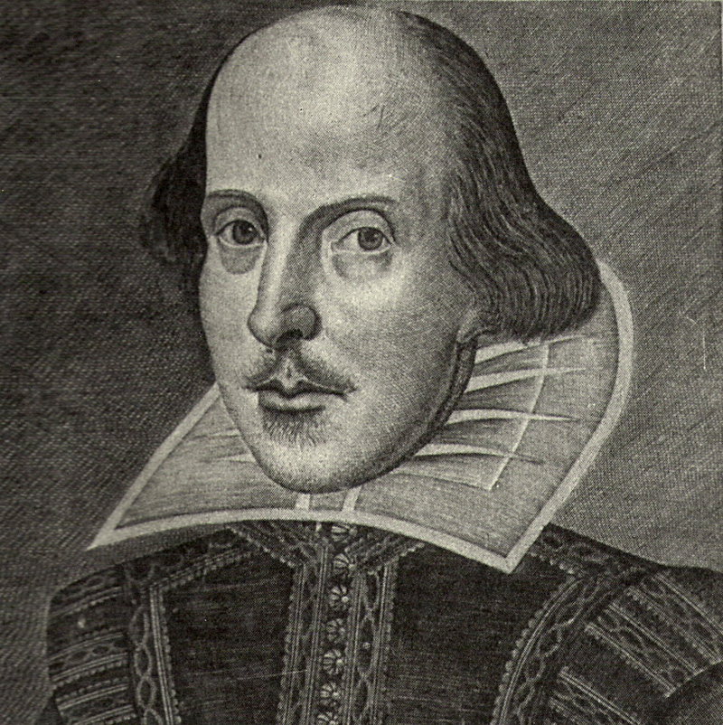
William Shakespeare – The Bard
Shakespeare's reputation as a dramatist and poet actor is unique and he is considered by many to be the greatest playwright of all time; however, many of the facts of his life remain mysterious.
William Shakespeare was born in Stratford-upon-Avon in Warwickshire, United Kingdom and was baptized on April 26, 1564. While his actual birthday is unknown, we celebrate it on April 23 of every year. His father was a glove maker and wool merchant and his mother, Mary Arden, was the daughter of a well-to-do local landowner. Shakespeare was probably educated in Stratford's grammar school from the ages of 7-14. The next documented event in Shakespeare's life is his marriage in 1582 to Anne Hathaway, daughter of a farmer. The couple had a daughter the following year and twins in 1585. There is now another gap, referred to by some scholars as 'the lost years', with Shakespeare only reappearing in London in 1592, when he was already working in the theatre.

Shakespeare's acting career was spent with the Lord Chamberlain's Company, which was renamed the King's Company in 1603 when King James succeeded to the throne. Among the actors in the group was the famous Richard Burbage. The partnership acquired interests in two theatres in the Southwark area of London, near the banks of the Thames - the Globe and the Blackfriars.

Shakespeare's poetry was published before his plays, with two poems appearing in 1593 and 1594, dedicated to his patron Henry Wriothesley, Earl of Southampton. Most of Shakespeare's sonnets were probably written at this time as well. Records of Shakespeare's plays begin to appear in 1594, and he produced roughly two a year until around 1611. His earliest plays include Henry VI and Titus Andronicus. A Midsummer Night's Dream, The Merchant of Venice and Richard II all date from the mid to late 1590s. Some of his most famous tragedies were written in the early 1600s including Hamlet, Othello, King Lear and Macbeth. His late plays, often known as the Romances, date from 1608 onwards and include The Tempest (One of Shakespeare’s most exciting and complex plays – and Mr. K’s favorite!).

Shakespeare spent the last five years of his life in Stratford, by now a wealthy man. He died on April 23, 1616 (the day we celebrate his birthday) and was buried in Holy Trinity Church in Stratford. The first collected edition of his works was published in 1623 and is known as 'the First Folio' and contained all of his plays save two.

The preceding article was taken from BBC’s Historic Figures archives and can be found at: http://www.bbc.co.uk/history/historic_figures/shakespeare_william.shtml
Did you know that Shakespeare is given credit for introducing nearly 2,000 words into the English language either by brining into usage foreign words, making conjunctions of two or three other words, using nouns as verbs, or by inventing new ones? Check out these words and phrases – that we still use today – attributed to Shakespeare.
Shakespeare
Said it
First

alligator | eyeball | jaded | mimic | rancorous
auspicious | eyesore | laughingstock | mountaineer | reinforcement
castigate | frugal | leapfrog | obscene | rumination
critical | gloomy | lonely | outbreak | torture
dauntless | gnarled | luggage | pedant | unmitigated
divest | hoodwinked | majestic | petition | worthless
equivocal | impede | manager | puke | zany
“all that glitters is not gold” “good riddance”
from The Merchant of Venice from The Merchant of Venice
“dead as a doornail” “heart of gold”
from Henry IV from Henry V
“elbow room” “sorry sight”
from King John from Macbeth
“full circle” “too much of a good thing”
from King Lear from As You Like it
Famous
Quotations

These Shakespearean lines are still well known today.

Friends, Romans, countrymen, lend  me your ears.  (Julius Caesar, Act III, Scene 2) | The course of true love never did run  smooth;  (A Midsummer Night’s Dream, Act I, Scene I)
Brevity is the soul of wit.  (Hamlet, Act II, Scene 2) | But I will wear my heart upon my  sleeve for daws to peck at: I am not  what I am.  (Othello, Act I, Scene 1)
All the world’s a stage, and all the men  and women merely players:  (As You Like It, Act II, Scene 7) | But be not afraid of greatness: some  are born great, some achieve greatness,  and some have greatness thrust  upon ‘em.  (Twelfth Night, Act II, Scene 5)
A horse! A horse! my kingdom for  a horse!  (Richard III, Act V, Scene 4) | We are such stuff as dreams are  made on, and our little life is  rounded with a sleep.  (The Tempest, Act IV, Scene 1)
What’s in a name? that which we call a  rose by any other name would smell as  sweet;  (Romeo and Juliet, Act II, Scene 2) | Double, double toil and trouble;  fire burn, and cauldron bubble.  (Macbeth, Act IV, Scene 1)

Combine one word from each of the three columns below, prefaced with "Thou” (thou means “you”):
Shakespeare
Shot
First!

Column 1 Column 2 Column 3

artless base-court apple-john
bawdy bat-fowling baggage
beslubbering beef-witted barnacle
bootless beetle-headed bladder
churlish boil-brained boar-pig
cockered clapper-clawed bugbear
clouted clay-brained bum-bailey
craven common-kissing canker-blossom
currish crook-pated clack-dish
dankish dismal-dreaming clotpole
dissembling dizzy-eyed coxcomb
droning doghearted codpiece
errant dread-bolted death-token
fawning earth-vexing dewberry
fobbing elf-skinned flap-dragon
froward fat-kidneyed flax-wench
frothy fen-sucked flirt-gill
gleeking flap-mouthed foot-licker
goatish fly-bitten fustilarian
gorbellied folly-fallen giglet
impertinent fool-born gudgeon
infectious full-gorged haggard
jarring guts-griping harpy
loggerheaded half-faced hedge-pig
lumpish hasty-witted horn-beast
mammering hedge-born hugger-mugger
mangled hell-hated joithead
mewling idle-headed lewdster
paunchy ill-breeding lout
pribbling ill-nurtured maggot-pie
puking knotty-pated malt-worm
puny milk-livered mammet
qualling motley-minded measle
rank onion-eyed minnow
reeky plume-plucked miscreant
roguish pottle-deep moldwarp
ruttish pox-marked mumble-news
saucy reeling-ripe nut-hook
spleeny rough-hewn pigeon-egg
spongy rude-growing pignut
surly rump-fed puttock
tottering shard-borne pumpion
unmuzzled sheep-biting ratsbane
vain spur-galled scut
venomed swag-bellied skainsmate
villainous tardy-gaited strumpet
warped tickle-brained varlot
wayward toad-spotted vassal
weedy unchin-snouted whey-face
yeasty weather-bitten wagtail

Check out some more of the Bard’s work and life while having fun at the following links:

Shakespeare Timeline:

http://shakespeare.palomar.edu/timeline/timeline.htm

Chat with Shakespearebot:

http://www.shakespearebot.com

Explore the Globe Theater where Shakespeare held many of his plays:

http://www.classbrain.com/artteensb/publish/interactive_globe_theater.shtml

Click on the “Poetry Machine” and create your own interactive poems:

http://www.shakespeare.com

Enjoy some puzzles and fun Shakespearean facts:

http://www.folger.edu/template.cfm?cid=588

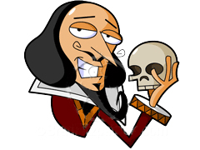

access them all at mrkawel.weebly.com

Is Shakespeare Truly Timeless?
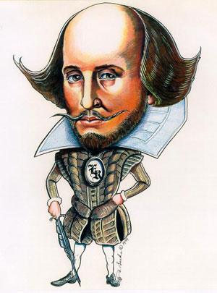
Final Paper for English Language Arts 8 with Mr. Kawel
Due no later than Tuesday, June 4, 2011 at the beginning of class

Assignment: Write a 5-paragraph persuasive essay in response to the following question:

Do you believe the work of William Shakespeare to be timeless?

- If you agree that the work of William Shakespeare is classic or timeless, then you need to persuade the reader to agree with you by providing examples that plainly show how it does translate well to modern times.
- If you do not believe that the work of Williams Shakespeare is classic or timeless, then you need to prove your position by providing examples of his work that plainly show how it does not translate to modern times.
- Remember that the purpose of a persuasive essay is to convince someone that your point of view is best.

Requirements:
- Minimum of 5 paragraphs (introduction, supporting paragraphs, and a conclusion)
- Your paper must have an introductory paragraph with a clear thesis statement that reveals your position on the question.
- Provide specific examples (quotations!) from the any of the following plays (specifically, the Lamb versions studied in class) to support your position:
  - Much Ado About Nothing
  - A Midsummer Night’s Dream
  - As You Like It
  - Merchant of Venice
  - Comedy of Errors (if studied)
  - Taming of the Shrew (if studied)
- Provide examples relevant to today’s society or culture that show how Shakespeare connects with today’s society or that show how Shakespeare’s work does not connect with today’s society (depending on your position).
- Acknowledge why some people might oppose your argument and explain why your response is stronger. Hint: use proof (quotations and examples!) to back up your argument!

- Your final draft must be typed or written in blue or black ink and free of grammatical/mechanical errors. One percent will be deducted from your final score for each grammatical/mechanical error found in the final draft.

Shakespeare Essay Scoring Rubric
Paper due no later than Tuesday, June 4, 2013 at the beginning of class

/ 20 points
Minimum 5 paragraphs (introduction, supporting paragraphs, and a conclusion)

/ 20 points
Paper has an introductory paragraph with a clear thesis statement that reveals writer’s position on the question.

/ 20 points
Provides specific examples (quotations!) from the any of the following plays (specifically, the Lamb versions studied in class) to support your position:
- Much Ado About Nothing
- A Midsummer Night’s Dream
- Merchant of Venice
- As You Like It (if studied)
- Comedy of Errors (if studied)
- Taming of the Shrew (if studied)

/ 20 points:
Provides examples relevant to our modern society and culture that show how
Shakespeare’s work connects with or does not connect with said society/culture.

/ 20 points
Acknowledges why some people might oppose your argument and explain why your response is stronger.

Subtotal

less 1% for every error
Typed or written in blue or black ink and free of grammatical/mechanical errors. One percent will be deducted from subtotal for each grammatical/mechanical error found in the final draft.

Total Score:

/ 100 points

William Shakespeare’s
Much Ado About Nothing
adapted from Tales from Shakespeare by Charles and Mary Lamb
- How are Hero and Beatrice related? __________________________________________
- What does Beatrice mean when she says that no one marks him?

- When referring to Benedick and Beatrice: “these two sharp wits never met in former times but a perfect war of raillery was kept up between them, and they always parted mutually displeased with each other.” Explain what happens when the two are together at Messina. Describe how they feel towards one another.

- What does the prince, Don Pedro, mean when he says to Claudio, “Do you affect Hero?”

- Why does Claudio really want “to make Benedick and Beatrice fall in love with each other?”

- What is Claudio’s ingenious plan? Does it seem to work?

- Who is Don John and why does he want to hurt Don Pedro so terribly?

- Who is Borachio and what is his role in Don John’s plan?

- What is the Friar’s plan to bring Claudio back to Hero?

- On page 60, it is said that the four lovers (Claudio & Hero; Benedick & Beatrice) developed such a powerful “affection” towards their partner through a false jest. Do you think it is possible to be “tricked into true love?” Explain your reasoning.

- This story, Much Ado About Nothing, has been around in one form or another for 450 years. What are some common themes or stories about our human condition that this play comments on? Identify the themes that are still present today. Why do you think this play was titled Much Ado About Nothing?

Dramatis Personae
Don Pedro, Prince of Arragon Friar Francis
Leonato, Governor of Messina (Innogen, Wife to Leonato)
Don John, Half-Brother to Don Pedro Hero, Daughter to Leonato and Innogen
Claudio, a young Lord of Florence, Friend to Don Pedro Beatrice, Niece to Leonato
Benedick, a young Lord of Padua, Friend to Don Pedro
Antonio, Brother to Leonato Margaret two Gentlewomen
Balthasar, Servant to Don Pedro Ursula attending on Hero
Borachio, Confidant to Don John
Conrade, Friend to Borachio

Dogberry, a Constable two foolish Officers
Verges, a Headborough

William Shakespeare’s
A Midsummer Night’s Dream
adapted from Tales from Shakespeare by Charles and Mary Lamb
- What could an Athenian parent do to their child if they refused to follow an arranged marriage?

- If your parent or guardian ordered you to stop dating someone whom you really care about, what would you be willing to do to see the person?

- If you were seeking revenge upon someone, what prank might you be willing to play to humiliate the person?

- What did Hermia mean when she said that Demetrius was as changeable as midsummer weather?

- Why was Duke Theseus sympathetic to Hermia’s plea? What choices did he give her?

- Why were the fairy king and the queen in a bitter quarrel?

- This story, A Midsummer Night’s Dream, has been around in one form or another for 450 years. What are some common themes or stories about our human condition that this play comments on? Identify the themes that are still present today.

Dramatis Personae
Theseus, Duke of Athens Oberon, King of the Fairies
Egeus, Father to Hermia Titania, Queen of the Fairies
Puck, or Robin Goodfellow
Lysander in love with Hermia
Demetrius

Philostrate, Master of the Revels to Theseus Pease-Blossom
Fairies
Quince, a Carpenter Cobweb
Snug, a Joiner Moth
Bottom, a Weaver Mustard-Seed
Flute, a Bellows-Mender
Snout, a Tinker
Starveling, a Tailor

Hippolyta, Queen of the Amazons, betrothed to Theseus
Hermia, Daughter to Egeus, in love with Lysander
Helena, in love with Demetrius
William Shakespeare’s
The Merchant of Venice
adapted from Tales from Shakespeare by Charles and Mary Lamb
- Who was the villain in this story? __________________________________________

- What was his profession? __________________________________________

- Who was the hero in this story? __________________________________________

- What was his profession? __________________________________________
- Why did Shylock and Antonio hate each other so much?

- Who was Antonio’s best friend? __________________________________________
- Why did he need to borrow money from Antonio?

- What did Antonio do to help out his friend?

- Who was Bassanio trying to marry? ________________________________ Why?

- After the two couples had agreed to marry, Bassanio received some really bad news. What news did the messenger bring?

- After Bassanio and Gratiano left to help Antonio, Portia put together a plan of her own to help Antonio. What was her plan?

- How was Balthazar able to free Antonio?

- The Duke gave Shylock a merciful sentence. What was that sentence and why was it merciful?

- What trick did Portia and Nerissa play on Bassanio and Gratiano after the trial?

- What promise did Antonio make to Portia at the end of the story?

- The Merchant of Venice has been around in one form or another for 450 years. What are some common themes or stories about our human condition that this play comments on? Identify the themes that are still present today.

Dramatis Personae
The Duke of Venice Shylock, the rich Jew, and father to Jessica
Morochus, a Prince, and a Suitor to Portia Tubal, a Jew, Shylock’s friend
The Prince of Arragon, Suitor also to Portia Portia, The rich Italian Lady
Bassanio, an Italian Lord, Suitor likewise to Portia Nerissa, her waiting-Gentlewoman
Antonio, A Merchant of Venice Jessica, daughter to Shylock

Salarino Leonardo, servant to Bassanio
Salanio Gentlemen of Venice, and Balthazar, servant to Portia
Gratiano Companions with Bassanio
Lorenzo

William Shakespeare’s
A Comedy of Errors
adapted from Tales from Shakespeare by Charles and Mary Lamb
- “The states of Syracuse and Ephesus being at variance…”
Explain what the word variance means. You may use the dictionary to help you.

- Aegeon said he did not fear death. What did he think was a heavier task that the sentence of death?

- What does Shakespeare mean when he writes, “the babes, who not knowing what to fear wept for fashion…” ?

- How did Antipholus of Ephesus become such a wealthy young man?

- What did Adriana think when her Dromio reported that her husband said he had no wife?

- How did the abbess trick Adriana into admitting, “she has betrayed me to my own reproof,” (explain the quotation)?

- Explain what the Duke meant by, “at once conjectured aright of these seeming mysteries.”

- Explain the following quotation: “The abbess suspecting this from the vehemence of Adriana’s manner…”

- Dromio says to his master, “Pray you jest as you sit to diner.” What does he mean?

- Are Antipholus and Dromio friends? How do they act as friends toward each other? When strange events start happening to them, does it drive them together, apart, or both?

- How are Luciana and Adriana different from one another? How do they relate to men? How do they react when they confront problems?

- The Comedy of Errors has been around in one form or another for 450 years. What are some common themes or stories about our human condition that this play comments on? Identify the themes that are still present today.

Dramatis Personae
Solinus, Duke of Ephesus Dr. Pinch, a Schoolmaster, and a Conjurer
Aegeon, a Merchant of Syracuse

Antipholus of Ephesus Twin Brothers, and Sons to Aemilia, Wife to Aegeon, an Abbess at Ephesus Antipholus of Syracuse Aegeon and Aemilia, but Adriana, Wife to Antipholus of Ephesus
unknown to each other Luciana, Sister to Adriana
Luce, Servant to Adriana

Dromio of Ephesus Twin Brothers, and Slaves
Dromio of Syracuse to the two Antipholuses

Balthazar, a Merchant
Angelo, a Goldsmith
A Merchant, Friend to Antipholus of Syracuse
A Second Merchant, to whom Angelo is a debtor
Iambic Pentameter
You probably already know that rhythm – or meter – is an important element of poetry. One of the most common rhythms used in poetry throughout the centuries is called iambic pentameter. Understanding this poetic rhythm will help you read and write poetry (Shakespeare!).

I. What is iambic pentameter?
Let’s look at these two terms separately. An iamb is a combination of stressed and unstressed syllables. Say the words between, mature, and instead. These are iambs. In poetry, repeated rhythmic units are called “feet.” An iamb is a kind of foot.
Pentameter means thst thr foot is repeated five times. It has the Greek root penta-, which means five (think of a pentagon; it has five sides).
Now put the two terms together: iambic pentameter is a line of poetry with five iambs in t. It has this rhythm:
da DUM /da DUM /da DUM /da DUM /da DUM
Try clapping it out!
II. What is iambic pentameter?
Iambing pentameter is the most common meter in poetry. William Shakespeare is famous for using it in both his plays and his poems. Check out this line from Macbeth:

So foul and fair a day I have not seen.
Macbeth, Act I, Scene 3

Now read the first four lines of Sonnet XVIII (by definition, a sonnet has 14 lines of iambic pentameter).

Shall I / compare / thee to / a sum / mer’s day?

Thou art more lovely and more temperate:

Rough winds do shake the darling buds of May

And summer’s lease hath all too short a date:

Your Turn

Clap out the rhythms of the sonnet. Then draw slashes in each line to show how they break into iambs. Finally, underline all the stressed syllables. I did the first line for you (see above).

III. Craft your Own Poem!
Writing in iambic pentameter requires thought and discipline to find just the right words. Create your own poem using iambic pentameter. If you don’t get the right rhythm or number of syllables at first, think about how you can rephrase your thoughts or use different words to express yourself. Use the lines below to write your poem. Continue on the back if you wish.

____________________/____________________/____________________/____________________/____________________

____________________/____________________/____________________/____________________/____________________

____________________/____________________/____________________/____________________/____________________

____________________/____________________/____________________/____________________/____________________

____________________/____________________/____________________/____________________/_________________

William Shakespeare’s
As You Like It
adapted from Tales from Shakespeare by Charles and Mary Lamb

Dramatis Personae
Duke Senior, living in exile in the Forest of Arden Sir Oliver Martext, a Vicar
Duke Frederick, his Brother and Usurper of the Dukedom William, a country Fellow in love with Audrey
Hymen
Amiens, Lords attending on Corin Shepherds
Jaques the banished Duke Silvius

Le Beau, a Courtier attending on Duke Frederick
Charles, Wrestler to Duke Frederick Rosalind, Daughter to the banished Duke
Celia, Daughter to Duke Frederick
Phebe, a Shepherdess
Oliver Twin Audrey, a country Wench
Jaques de Boys Sons of Sir Rowland de Boys
Orlando Touchstone, a Clown

Adam
Dennis

