EQS: What were the positive and negative consequences of westward expansion?
  - What positive and negative consequences did non-Americans experience as a result of American westward expansion?
  - What positive and negative consequences did Americans experience as a result of American westward expansion?
  - What conclusions can be drawn about the United States’ relationship with American Indian relations as a result of the Trail of Tears and period of American Indian removal?
----------------------------------------------------------------------------------------------------------------------------------------------
The BIG Idea:
After the American Revolutionary War and the War of 1812 (both with the British!), the United States developed a strong sense of national pride called nationalism. The nation also began to value the use of diplomacy over war to settle differences with other nations.
**__________________________________________________ is the art of dealing with people or foreign nations in a sensitive and effective way.____________________________________________________________________________________________
After using the yellow highlights in Chapter 9.1-9.2 (pp. 298-307), Chapter 10.1-10.3 (322-335), your textbook’s glossary, and the dictionary (you’ll need it!) to help you, record a simple definition for each of the following terms:

9.1: American Foreign Policy | Louisiana Purchase
 | Rush-Bagot Agreement
 | Convention of 1818
 | James Monroe
 | Adams–Onís Treaty
Monroe Doctrine

1.

2.

3.

4.

9.2: Nationalism and Sectionalism | Nationalism
 | Henry Clay
 | American System
 | Cumberland Road
9.2: Nationalism and Sectionalism | Erie Canal
 | Era of Good Feelings (aww…!)
 | Sectionalism
Missouri Compromise

1.

2.

3.

 | John Quincy Adams
10.1: Jacksonian Democracy | Nominating conventions
 | Jacksonian Democracy
 | Democratic Party
 | John C. Calhoun
 | spoils system
 | Martin Van Buren
10.2: Jackson’s Administration | states’ rights doctrine
 | Tariff of Abominations
 | nullification crisis
 | Daniel Webster
 | McCulloch v. Maryland
 | Whig Party
 | Panic of 1837
10.3: Indian Removal | Indian Removal Act
 | Indian Territory
 | Bureau of Indian Affairs
 | Worcester v. Georgia
 | Trail of Tears

9.1: American Foreign Policy
- The __________________________________________________ set the border between the United States and Canada at 49º N latitude as far west as the Rocky Mountains.
- The __________________________________________________ settled all border disputes between Spain and the United States.
- This exclusive statement of American policy warned European powers not to interfere with the Americas (North and South America): __________________________________________________.
- The __________________________________________________ limited naval power on the Great Lakes for both the United States and British-controlled Canada.
9.2: Nationalism and Sectionalism
- __________________________________________________ is feelings of pride and loyalty to a nation.
- The __________________________________________________ was a time of peace, pride, and progress for the United States of America that lasted from 1815-1825.
- The __________________________________________________ settled the conflict that had arisen from Missouri’s application for statehood. It had three main conditions that are listed in my vocabulary dictionary.
- __________________________________________________ is disagreements between different regions of a country. Northern and Southern states suffered from this throughout the 1800s. Eventually, this would help lead to the American Civil War.
- The __________________________________________________ was an economic plan originally called the “American Way.” It was a series of measures intended to make the Unite States economically self-sufficient that included:
  - A tariff or tax on foreign goods intended to protect American-made products
  - The formation of a national bank that would provide a single currency to make trade easier
  - Money from the federal government to build roads and canals for easier transport of goods and people
10.1 and 10.2
- The __________________________________________________ formed in support of Andrew Jackson’s candidacy for President.
- __________________________________________________ are events where political party members choose their party’s candidates instead of the party leaders taking full responsibility.
- The practice of giving government jobs to political backers or supporters (people who give you money!) is called the
__________________________________________________.
- The nickname given to a high tariff imposed by Congress before Andrew Jackson’s presidency was called the
__________________________________________________.
- The __________________________________________________ said that since the states had formed the national government, state power should be greater than federal power.
- The dispute between supporters and opponents of nullification was called the
__________________________________________________.
- This Supreme Court case saw the court rule in favor of the national bank:
__________________________________________________.
- This political party favored the idea of a weak president and a strong Congress:
__________________________________________________.
- Almost immediately after Jackson left office, the nation suffered the
__________________________________________________ - a terrible economic depression.

For the following pages, determine who each of these significant figures are by using their picture and biography.
James Monroe John Quincy Adams Andrew Jackson
Martin Van Buren William Henry Harrison Henry Clay
Daniel Webster John C. Calhoun

Picture | Who am I? | Biography
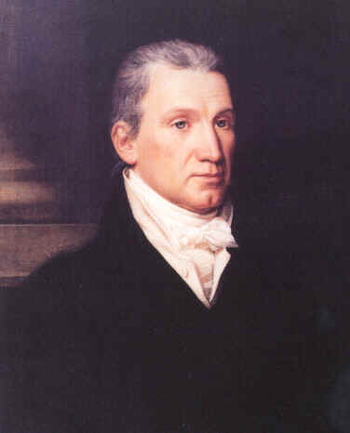 |  | Elected in 1816, I served as the fifth President of the United States. I decided to use diplomacy instead of war to deal with other countries.  I issued the Monroe Doctrine to show the rest of the world that the United States doesn’t mess around.  I supported the independence of Latin American nations from Spain.
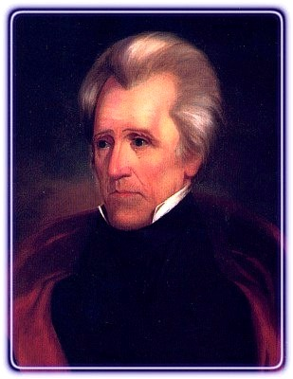  “Old Hickory” |  | I defeated the British army during the War of 1812 at the Battle of New Orleans. Going up against 8,000 troops, my units only suffered 71 casualties. Yes, I schooled the British.  I also served as the seventh President of the United States and was the only President who successfully reduced the nation’s debt to zero – but then things went downhill pretty quickly.  Oh yeah: I killed a man in a duel. After he shot me in the chest.
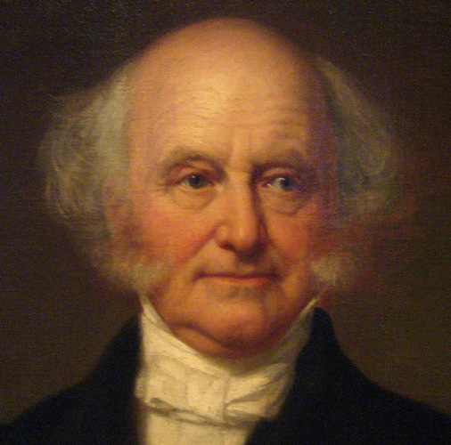 |  | I served as the eighth President of the United States after having served as secretary of state under Andrew Jackson.
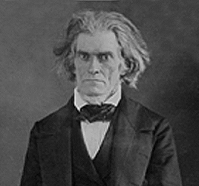 |  | Other than appearing to be the most terrifying man to ever play a role in American politics, I served as President Andrew Jackson’s first Vice President and was a legislator from South Carolina.  I was a strong supporter of slavery and states’ rights, and was a chief player in the nullification crisis.

Picture | Who am I? | Biography
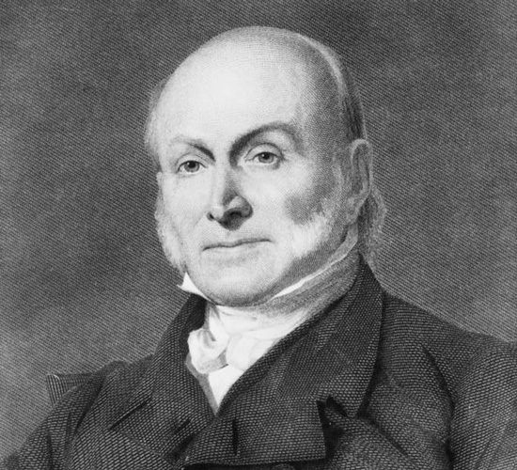 |  | I also served as President of the United States. The sixth POTUS, in fact. My father was John Adams (the second POTUS!).
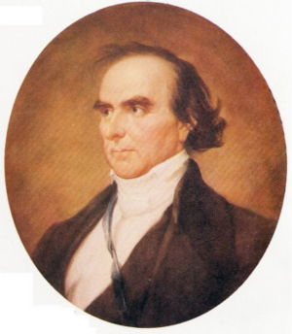 |  | I was a statesman from Massachusetts and I believed that the welfare of the United States nation as a whole should supersede (or have power over) states’ rights. I did not support nullification or states’ rights over the nation’s rights.  John C. Calhoun and I did not get along that well.
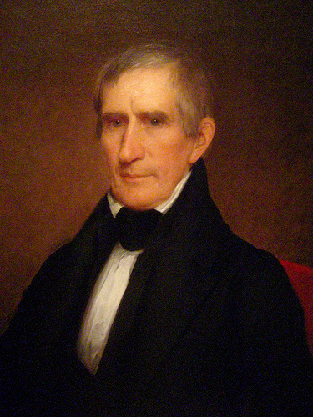 |  | I served as the ninth President of the United States but only served for 32 days having died from pneumonia complications! I was the first of four presidents from the Whig political party.  I also served as governor of Indian Territory and I fought Tecumseh in the Battle of Tippecanoe.
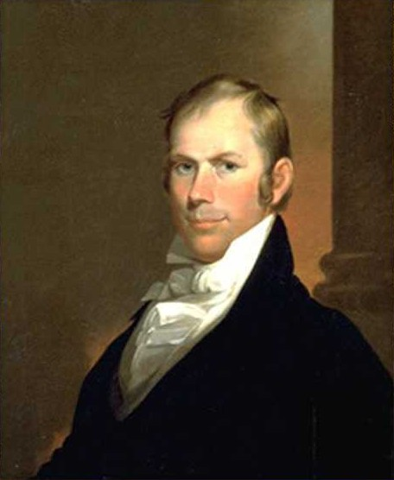 |  | I was a politician from Kentucky known as the Great Pacificator. I was also known as the silver-tongued Kentuckian because of my great speaking skills.  I worked very hard to preserve the Union (or, keep the country together) was a strong supporter of the Missouri Compromise, and I developed the Compromise of 1850 to avoid civil war.

